**Git Merge Terms**

* Fast Forward Merge vs Three-way merge (merge)

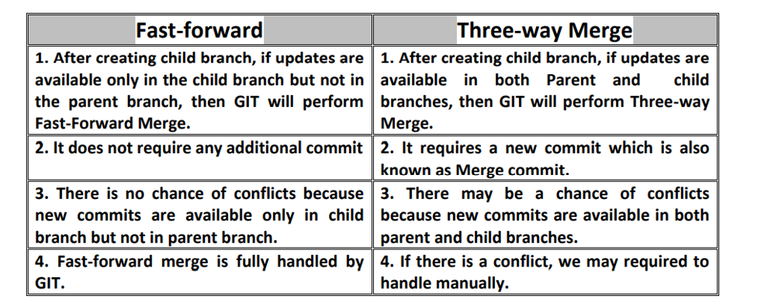

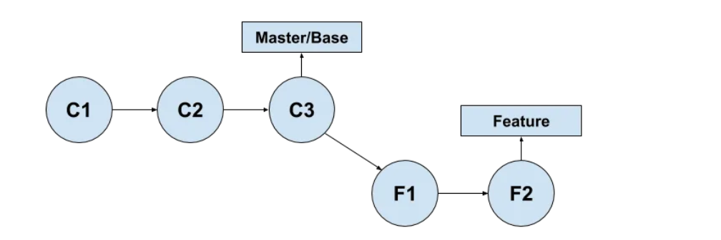

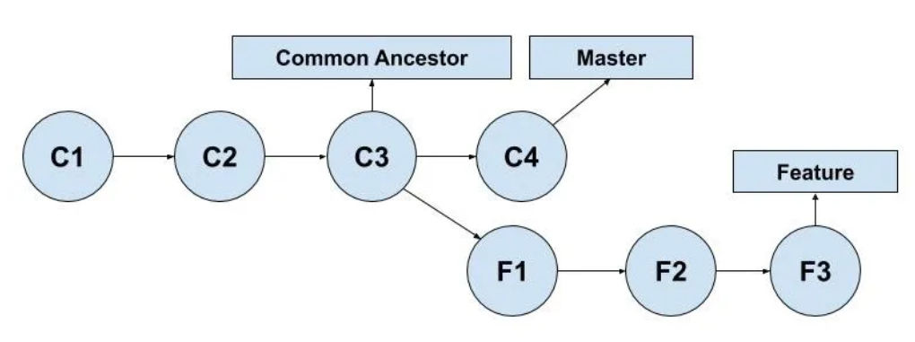

* Rebase

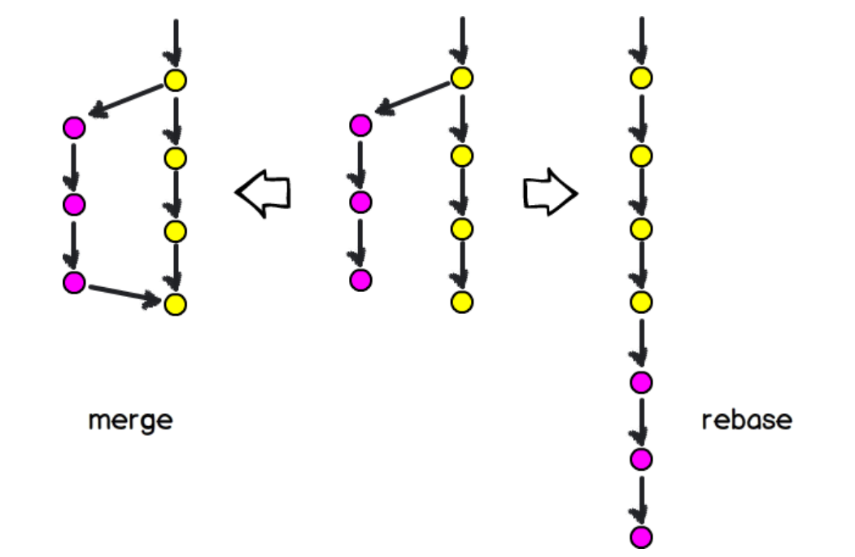

Cherry pick:

Picking some’s commit into our change.

Example: in TBT branching strategy, we need pick someone commit if we are running behind them.